Otto-von-Guericke-University Magdeburg

Faculty of Electrical Engineering and Information Technology

Chair for Electromagnetic Compatibility

Degree Thesis



Characterization and Automated Alignment Detection of an Additively Manufactured Z-frame Marker to Process Signals for Robotic Control in Interventional MRI

Submitted: August 01, 2018

By: Parisa Parsanejad

Born on June 23, 1991

In Esfahan, Iran

**Abstract**

Task of the Thesis in the Origin:

Declaration by the candidate

I hereby declare that this thesis is my own work and effort and that it has not been submitted anywhere for any award. Where other sources of information have been used, they have been marked.

The work has not been presented in the same or a similar form to any other testing authority and has not been made public.

Magdeburg, August 01, 2018

1 Introduction 12

1.1 Motivation 12

1.2 Objectives 12

2 Literature Survey 13

2.1 Magnetic Resonance Imaging (MRI) 13

2.1.1 Artifacts in MR imaging 13

2.1.1.1 Chemical shift artifacts 14

2.1.1.2 Phase cancellation artifact 17

2.1.1.3 External artifacts 17

2.2 Instrument tracking methods in interventional MRI 20

2.2.1 Investigated tracking methods 21

2.2.2 Passive MRI marker tracking 24

2.3 Principal of Z-frame marker 26

3 Methodology 30

3.1 Alignment detection algorithm 30

3.1.1 Data acquisition 33

3.1.2 Image segmentation and Pre-Processing 35

3.1.2.1 Z-frame marker extraction 36

3.1.2.2 Automatic detection of Z-frame marker using Faster R-CNN 36

3.1.2.3 Noise removal of MRI images 43

3.1.2.4 Image Contrast Enhancement 50

3.1.2.5 Image Binarization 50

3.1.2.6 Binary Image Mask 51

3.1.3 Localization and Registration 52

3.1.3.1 Center Detection of the Fiducial Ellipses 53

3.1.3.2 Image Rotation Estimation using Automated Feature Matching 54

3.1.3.3 Image Rotation using centroids coordinate system: 56

3.1.3.4 Distance calculation and calibration 58

3.1.3.5 Marker Alignment Calculations 59

3.1.3.6 Angle Calculation of the MR Image Plane and Z-Marker 60

3.2 Graphical user interface implementation 65

3.3 Z-frame marker characterization 71

3.3.1 Z-frame physical structures 71

3.3.1.1 Center pointing triangles 71

3.3.1.2 Z-axis indication triangle 73

3.3.1.3 Squared-shaped internal tunnel structure 74

3.3.2 Z-frame marker spectroscopy 75

3.3.2.1 Determination of the resin relaxation times 75

3.3.2.2 Experimental results 77

3.3.2.3 Outlook 78

3.4 MR-compatible rotatory frame 80

4 Testing 82

5 Results 83

5.1 Accuracy study 83

5.1.1 CAD model 83

6 Conclusion and outlook 85

List of Acronyms

List of Figures

List of Table

# Introduction

## Motivation

## Objectives

# Literature Survey

## Magnetic Resonance Imaging (MRI)

MRI is a non-invasive imaging technology generating three dimensional anatomical and functional images of the body without the use of ionizing radiation. It is particularly useful for neurological, oncological, cardiovascular, muscular and skeletal imaging. MRI employs a powerful magnetic field that forces the hydrogen atoms in the tissue being imaged to align with its axis. The additional radiofrequency fields are then used to stimulate the protons and alter the alignment of the magnetization. When the radiofrequency fields are turned off, the protons realign with the magnetic field and release the detectable energy by the MRI scanner.

In order to acquire the MRI images in a desired manner such that the tissues of interest are optimally distinguishable from the background, multiple pulse sequences have to be chosen appropriately. Three general criteria are available in MR imaging technique to modify the measurement parameters of a pulse sequence depending on the anatomical structure under observation, such as sufficient scan time, acceptable spatial resolution, and the adequate contrast between tissues. For example, the required imaging parameters for brain tissues are different in comparison with the imaging setup for the bone structures. In spite of the non-ionizing radiation characteristics, MRI imaging experiences different imaging artefacts which generate difficulties for the detection and registration task. The most common artifacts in MRI are investigated in this section which assist optimization of the detection algorithm and physical marker structure design.

### Artifacts in MR imaging

In magnetic resonance imaging (MRI), artifacts are defined as the pixels that do not truly represent the anatomy being analyzed. Commonly, artefacts are divided into three groups based on the nature of the pixel distortion. The first group refers to the artefacts that are produced by the patient movement during the data acquisition process. Blood flow and respiratory motion are the most common causes of the motion artefacts in MRI. The second group of artefacts refer to a consequence of the suboptimal imaging parameters, However, the signal misregistrations in this case can be easily recognized because the source of these artefacts is relatively constant during the measurement. The final group of the artifacts is generated from an external source, such as patient monitoring systems. The full explanation about artifacts are given in []. In this project the most important ones are discussed.

#### Chemical shift artifacts

Chemical shift artifacts emanate from the 3.5 ppm resonance frequency difference between fat and water protons as it is shown in Figure 2.3 and 2.4.



3.0 T

1.5 T

(b)

(a)

Figure ‎2.3: Spectrum of water and fat. The frequency difference between water and fat is 3.5 ppm which is equal to 220 Hz and 450 Hz absolute frequency difference in the presence of 1.5T and 3,0T magnetic field. (a) 1.5T magnetic field. (b) 3.0T magnetic field.

One consequence of this frequency difference is the misregistration of the fat and water protons which are mapped to incorrect pixels from a voxel.

According to the Equation 2.1, the detected signal from a voxel is positioned in a specific location based on its frequency if all protons inside a voxel have the same resonate frequency:

$B_{i}=B_{0}+G_{T} ⨂ r_{i}$ (2.1)

In the Equation, $B_{0}$ is the main magnetic field, $B_{i}$ is the magnetic field at location $r_{i}$ and $G_{T}$ is the total gradient amplitude.



Figure ‎2.4: Figure 2.4 Precession of fat and water protons. Due to the frequency difference between fat and water protons, water protons precesses faster than fat protons.

However, due to the fact that fat and water protons have a different molecular structure, they have a lower resonate frequency than water protons in a same gradient field. Accordingly, they will be transferred to a lower frequency pixel in the readout direction by the same GRO within a voxel. This misregistration is not perceivable in the consistent fat-water tissues. However, at the borders between tissues with an indicatively different fat-water content, the chemical shift artifact is significantly visible that is shown in Figure 2.5. The number of pixels resembling chemical shift artifact can be estimated according to the Equation 2.2:

$CAS = Δ_{ω}*N_{RO}∕Bw_{REC}$ (2.2)

Where $Δ_{ω}$ represents the frequency difference between fat and water protons in a voxel, $Bw_{REC}$ is the total receiver bandwidth, and $N_{RO}$ corresponds to the number of readout data points spanning the FOVRO.



(b)

(a)

Figure ‎2.5: Chemical shift artifact. (a) The light and dark lines at the boundary between the vertebrae and disk (arrows). The image is acquired using spin echo sequence and the receiver bandwidth of 20 Hz. (b) An intense chemical shift artifact in the skull (arrow). The image is acquired using spin echo pulse sequence in phase-encoding direction.

The effect of the chemical-shift artifact on MR images of the conventional Z-frame marker is provided in Chapter.

#### Phase cancellation artifact

Phase cancellation artifacts also arise from the precessional frequency difference of fat and water protons. Exclusively, this kind of chemical shift-based artifact occurs in gradient echo images. As it is illustrated in Figure 2.6, the artifact leads to a black line around the boundary of the tissue because of the destructive interference of signals from the pixels containing fat and water protons.



(b)

(a)

Figure ‎2.6: Phase cancellation artifact. (a) In this image (TE,4.5 ms) fat and water protons have the same phase; therefore, no phase cancellation artifact is visible. (b) In this image (TE, 2.2 ms) fat and water protons have the opposite phases; therefore, a dark band has been produced at the interference between liver and kidney (arrows).

#### External artifacts

This type of artifacts results from the MRI hardware miscalibration or the external electrical devices around the MRI scanner. However, the severity of the artifact in the image depends on the special source of the artifact as well as the imaging parameters.

* Noise

Noise is the final artifact present in the MRI images. It has different appearances based the nature of the source. A common type of noise is known as spikes that occur randomly during the image acquisition. As it is shown in the Figure 2.7, spikes appear as waves in the image, and are mostly generated by electrical components.



Figure ‎2.7: Spikes. The electrical discharge during the image acquisition generates the spikes as a banding pattern in the image. The distance between bands depends on the discharge duration.

The second type of noise appears as constant frequency lines in the image as it is represented in the Figure 2.8. They can emanate either from the altering standard electrical or, electrical connections in the scanner room.

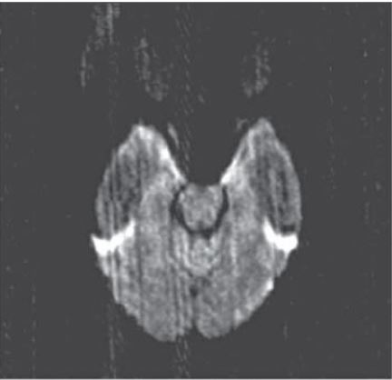

Figure ‎2.8: Noise. The electrical connections outside the scanner room produce the artifact in the image.

(intensity inhomogeneity part of the sample should come to the external artifacts and mix together.)

As explained, different available sources of artifact and noise in MRI degrade the images and make image processing and registration tasks more difficult. Consequently, the Z-frame has to be designed in a way which produce less artifacts in the image, the imaging parameters have to be optimally selected to reduce the artifacts, and the processing algorithm has to be developed to filter as much as noise possible without effecting on the relative signal. In section several materials are compared to evaluate their in MRI. Section gives a comparison between the most practical methods for MRI noise removal, and their performance are assessed.

## Instrument tracking methods in interventional MRI

iMRI is an appropriate technique for many types of minimal invasive procedures mostly in the field of biopsies, catheter placement and ablations due to its mentioned advantageous in section 2.1. For the visualization of the instrument (e.g. biopsy needle or radio frequency ablation needle) during its progressive penetration to the target structure the imaging signal is constantly being updated in iterative acquisition with a duration of several seconds each to approach real-time or interventional MRI-guidance. Since all instruments must be MRI-safe, meaning that they are not attracted by the magnetic field, they do not provide a proton-based resonance signal but are either indirectly visible by the typical artifact that they are creating or completely invisible. In this case the orientation of the interventional instrument must be distinguished with alternative methods to acquire precise alignment information. For this purpose, there are multiple solutions used in interventional applications. The most established one is free-hand instrument guidance which the desired trajectory of the instrument is planned by the surgeon using her finger straight before the actual percutaneous puncture with the instrument (Figure). However, this approach requires iterative movements either from the clinician or of the patient table in and out of the MRI-tunnel, which is cumbersome, time-consuming and expensive with respect to the costs of the intervention.



Figure ‎2.9: MR-images of a liver biopsy procedure with the clinician’s hand indicating the desired puncture point and needle alignment, which is demonstrated by pressing the finger-tip and the finger axis (left: dent in the skin and green line placed above the finger axis), and guiding the needle during its penetration through the fat-layer (middle) until the target area is reached (right).

The common investigated tracking methods of the robotic and manual instruments in MRI image space are described in this chapter.

### Investigated tracking methods

Joint encoder tracking:

In this method, the position and orientation of the device (such as mechanical, semi-autonomous- or robotic-devices) is estimated using the device’s join encoders. This method requires the device be fixed to the MRI scanner by a rigid mechanical mounting system and accurately be calibrated according to the scanner coordinate system. However, fixing the device at the defined coordinate system for each procedure is complicated and time-consuming. (Krieger et al. 2011; Robotics: Science and Systems X 2014; Cepek et al. 2014)

Figure 2.9 illustrates the configuration of a MRI compatible surgical assist robot proposed by Chinzei et al. The mechanical body of the robot is located above the surgeon’s head that should be fixed in the same position for all the procedures.

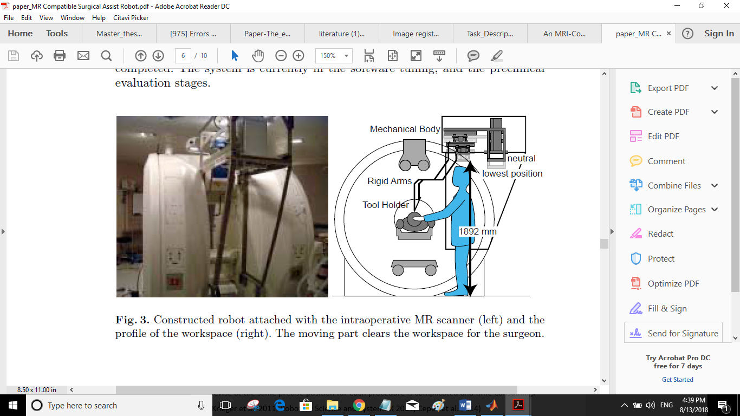

Figure ‎2.10: The configuration of the robot in MRI. The robot is attached to the MRI scanner in a specific position. (paper_MR Compatible Surgical Assist Robot)

Optical pose tracking

In this approach, an optical tracking system is used for the localization of the interventional device based on the scanner’s coordinate system. However, this technique requires a free line-of-sight between the device and the optical camera. In addition, retroreflective spheres or sterilizable LEDs must be attached to the interventional instruments to ascertain the position of the instrument tip. (Krieger et al. 2011). Figure 2.10 shows an optical tracking system attached to a MRI compatible robotic device for conducting the registration and tracking tasks.



(a)

(b)

Figure ‎2.11**:** Optical tracking system integrated with an MRI compatible robot (a) Open-MRI scanner (GE Signa SP), (b) MR-compatible robot..

Gradient field sensing

In this method, a tethered-axis magnetic sensor which is embedded within the interventional device, determines the position and orientation of the device. The main principle of this method is the measurement of the scanner gradient field and transforming to the pose of the device using a gradient field sensor. The implemented sensor is made by three orthogonal coils that can have different sizes and shapes, to fit the specific application. However, this approach requires a precise one-time calibration procedure to be performed over the entire field of interest in each MRI system on which it is installed.

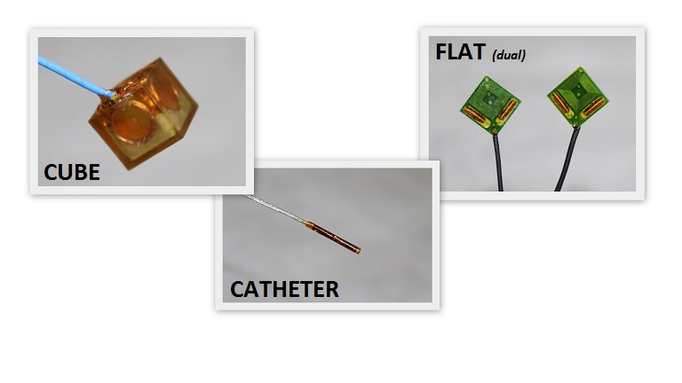

Figure ‎2.12**:** Gradient field sensor. According to the specific application, each type of sensor can be applied for tracking of the pose of the device in iMRI.

Active Coil Tracking

In this technique, small radiofrequency (RF) receive coils are embedded within the interventional device to establish a connection between the coil and the MRI RF-receiver channel. During the procedure, the associated coil coordinates are repeatedly computed; thus, the image slice is aligned with the device between two real-time images (Bock et al. 2006). The main drawbacks of this approach are the need for several scanner channels, and the custom-programmed tracking sequences.

### Passive MRI marker tracking

Passive tracking in MRI is defined as embedding fiducial markers within the device for tracking of the device pose by localizing the fiducial markers. The known geometric configuration of the fiducial markers assists to relate the device’s and MR’s coordinate systems. The main advantage in this approach is the simpler calibration method of the markers inside the MRI coordinate system, because both the interventional device and the patient’s anatomy can be observed in the same image space. However, a compromise between the acquisition time and the image resolution has to be considered for an accurate and reliable marker localization. Moreover, diagnostic MRI systems are not equipped with the required imaging systems for interventional guidance that makes the tracking and registration of the tracking marker more difficult.

(S.P. DiMaio, E. Samset, G. Fischer, I. Iordachita, G. Fichtinger, F. Jolesz, and C.M. Tempany)

To overcome these problems, chapter 4 introduces a new registration approach, which is able to achieve concurrent registration in a desired target alignment from a single slice image using a new-designed Z-frame marker. The main strength of this registration approach is its compatibility with all the MRI systems without the need for any special interface.

## Principal of Z-frame marker

For tracking the instrument´s alignment in reference to its planned trajectory, the fiducial marker frame from Brown-Roberts-Wells, which is also called Z-frame based on its design of the fiducial marker structures, has been published many times as a concept for possible application in MRI-guided interventions. The marker is designed on the principle of a solid body that is crossed by a three-sided Z-shaped tunnel filled with liquid marker material. There are four vertical tunnels in every edge of the body and three 45° diagonal tunnels connecting all four vertical tunnels in three side faces of the body. Once the marker is measured in the MRI the tunnel structures are visible in a 2D-image plane as a very distinct pattern of seven circular areas, see Figure 3.1.



Figure ‎3.1: left: Design principle of the Z-Marker with four vertical (z-direction) and three 45°‑diagonal tunnel structures filled with a marker fluid. The pointed image plane crosses all seven tunnels in perpendicular position to the Z-axis. Right: The Z-marker in a 2D-MR-image with view in +Z-direction and with all calculated center points of the circular areas [996].

With the measurement of all distances between the circular areas, the marker alignment can be fully calculated in six degrees of freedom (6-DOF) in reference to the image plane alignment in the MR-image. However, the published marker concepts lacked in their fiducial characteristics or the feasibility for clinical application. Most reasons for it are founded in the design that has always been based on using at least two materials: one for the solid body and one for the fiducial liquid which is enclosed by it. For instance, the Z-frame-marker can be fabricated out of seven plastic capsules, which are filled with MRI-visible liquid (e.g. gadolinium: Gd, MR-SPOT® 121, Beekley Corp., Gd-capsule length: 32.0 mm, inner diameter: 6.2 mm) and that are placed inside the internal, z-shaped tunnel structures of the solid body, see Figure 3.2 left. Another method that has been applied for the Z-marker fabrication is the direct filling of a solid body with internal Z-shaped tunnel structures. This is made by one bore-hole which needs to be sealed up after filling, see Figure 3.2 right. That method owns the disadvantages for a complex and expensive fabrication process and a high risk for leakages.



Figure ‎3.2: Z-marker concept with Gd-based marker capsules inserted into a solid body frame (left and middle). Design concept with marker liquid directly injected into tunnel structures of the marker body but requiring additional sealing (right) [4, 995 - please update].

The mentioned method has the disadvantage that the plastic wall of the capsule, which is located between the body´s wall and the beginning of the MRI-visible liquid, can affect the precision of the marker detection negatively by shifting the center points of each tunnel due to geometric irregularities. Another issue that affects the marker precision in this design can be caused by the potential of certain artifacts. If the chemical shift artifact of a liquid marker material is too high, there is a relevant shift of the real center point to a virtual center point that results from the accumulation of the fat-based signal and the water-based signal. In worst case the geometric irregularities are superimposed with the chemical shift based irregularities leading to a significant inaccuracy of the precision of the marker [4 *- please update*].





Figure ‎3.3: Overview on potential geometric defects for fiducial markers using Gd-filled capsules (left and middle) and effect from the interpolated center point between the fat- and water-based circular artifact areas (right) [please update].

In this project, a new concept for a fiducial marker is presented that is fully additively manufactured (commonly known as rapid-prototyping = RP) with only one polymer material. This one material is used for the fabrication of the solid Z-marker body and the internal marker liquid by using the method of stereolithography (SLA) technology [4 *- please update*]. The fabrication material for the marker-model is a liquid and photosensitive polymer, which is locally hardened by a laser beam. The model is built up layer by layer with the laser beam hardening the model volume. The principle of the SLA-method allows the enclosure of defined geometrical structures filled with unhardened liquid resin. These structures are created inside the solid model body without any openings to the outside. For this reason, only the structure surrounding the desired marker-geometry is hardened by the laser. The marker-geometry itself remains a liquid. Since it is made entirely from polymeric material, this marker is passive and totally MRI-safe. Section 3.1 and 3.2 describe the physical and chemical characteristics of the additively manufactured Z-frame.

# Methodology

This is divided into three parts:

## Alignment detection algorithm

The implemented algorithm for automated alignment detection of the Z-marker consists of the several steps. At first, the Z-marker structures are extracted from the images and the centroids of the fiducials are computed. This stage is presented in section 4.2, where different filtering methods for noise suppression and feature enhancement are introduced. The next stage is localization and registration of the Z-marker in MRI coordinate system that is discussed in section4.3. In this work, a new registration procedure is proposed, which uses several mathematical calculations for the successful accomplishment of the task. The mentioned methods in this chapter are implemented in Matlab R2017a and R2018a. The system configuration and flowchart of the procedure is shown in Figure 4.1 and 4.2.

Scanner Room

Robotic Device and the Z-marker

MRI Scanner

Robot Controller

MRI Hardware

Control Room

MRI Host Workstation

Navigation Workstation

Capture Device

**Figure 4.1**: The system configuration and the data flow during the tracking and registration procedure. Once a single 2D image is acquired by the MRI scanner and is transferred via the MRI host workstation, the capture device acquires a snapshot of the MRI monitor for processing in navigation workstation. The required motion of the Z-marker and robotic device is calculated in navigation workstation and will be commanded to the robotic device via robot controller.

Localization and Registration

Image Segmentation and pre-processing

Fiducial Center Detection

Z-marker Detection

Image Noise Removal

Image Rotation Estimation

Image Binarization

Distance Calculation and Calibration

Contrast Enhancement

Marker Alignment Calculation

Binary Masking

Parallelization Estimation

**Figure 4.2:** Flowchart of the automatic alignment detection of the Z-marker.

### Data acquisition

In this project a new image acquisition setup is proposed to facilitate the registration process in a nearly real-time workflow. The setup of the procedure is shown in Figure 4.3, where a capture device (Hauppauge- HD PVR 2) is used in a loop between MRI monitor and the processing laptop. Therefore, each data on the monitor screen is shown and saved on the processing laptop.



AV Converters

MRI Monitor

Processing-Laptop

Capture Device

**Figure 4.3:** Setup configuration of the image acquisition procedure.

In addition, decoding of the protected patient data imaging is needed to adapt the setup flexibly and the fast installation in different MRI-systems. Accordingly, two converters are used to decodes the data in two stages. It has to be mentioned that the converters effect the quality and resolution of the decoded images, therefore, two types of the decoders have been tested in this work to verify their applicability in the setup. Figure 4.4 shows a comparison of the quality of the image acquired by the capture device without decoding (Figure 4.4c), and with decoding using two types of converters; HDMI to VGA (Figure 4.4a) and HDMI to AV (Figure 4.4b). As it is represented in the image 4.4 using the VGA converter provides the images with higher resolution and contrast than the AV converter. However, in this work the AV converter is used since it is more compatible with MRI hardware system. Figure 4.5 shows a snapshot of the MRI screen from a T1W image of the Z-marker using capture device and AV converter.





(c)

(b)

(a)

**Figure 4.4:** One image is used to represent the VGA and AV converters influence on the resolution of the captured image. Image “a” is captured by using the capture device and the AV converter. Image “b” is captured using capture device and the VGA converter. Image “c” is captured using only the capture device and with HDMI cable (HDMI resolution). The red ellipses in the “a” and “b” images show the position where are different from the image “c”.

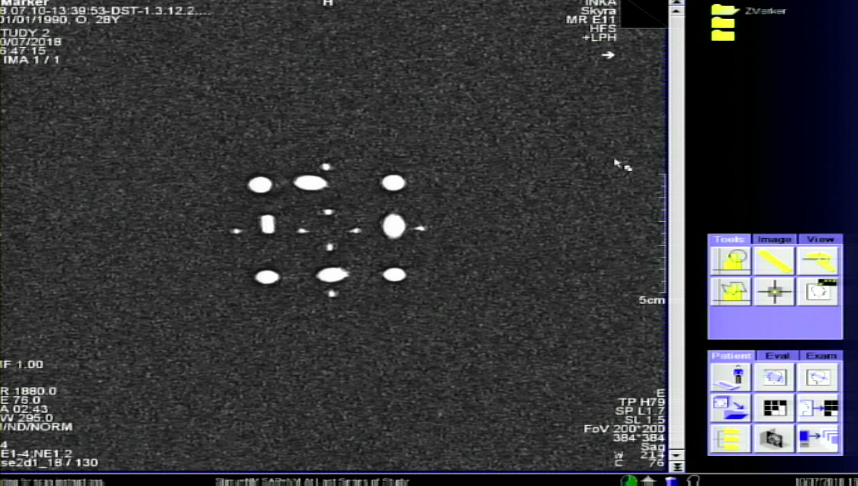

**Figure 4.5:** a snapshot of the MRI screen from T1W image of the Z-marker using the setup shown in Figure 4.2.

### Image segmentation and Pre-Processing

After an image from a single 2D image of the Z-marker has been obtained, the Z-marker structures should be detected from the captured-image of the MRI screen. Section 4.2.1 discusses a manual and an automatic segmentation method to separate the Z-marker from the other objects in the image. Subsequently, several filtering steps are applied to the cropped image to segment each individual ellipse of the Z-marker from the background. These steps are developed and investigated in section 4.2.2. The flow chart of the detection and localization algorithm is shown in Figure 4.2.

#### Z-frame marker extraction

Detection of the Z-frame marker in different position, orientation and scaling from the MRI images is a very important step to determine the marker alignment. One way to separate the Z-marker from the full-screen image is using the mouse to perform the crop operation interactively by defining a movable and resizable bounding box over the region of interest Figure 4.6.



Figure ‎4.1.6: cropping operation for extracting Z-marker manuaaly by MATLAB



Crop rectangle

Crop Image tool context menu

#### Automatic detection of Z-frame marker using Faster R-CNN

However, this technique requires the user to repeat the process separately for each new image. In this study, a deep CNN framework is implemented with non MRI-system-specific design to perform the detection process automatically. This algorithm is able to detect the marker from the images with different imaging properties and different MRI user interfaces.

Commonly, there are three main frameworks in object detection based on deep CNNs. Regions with CNN features (RCNN), Fast Region-based Convolutional Network (Fast RCNN), and Faster Region-based Convolutional Network (Faster RCNN). However, in the image from the MRI monitor, there are many small and big objects, therefore, the use of the Faster RCNN yields a higher accuracy for the object detection task.

* Convolutional neural network structure

CNN is made of several layers, a convolution layer, a feature pooling layer, and a fully connected (FC) layer. Figure 4.7 shows the flowchart of a CNN.



Pool2

Pool1

CONV1

CONV2

**Figure 4.7:** Flowchart of convolutional neural network.

At the *convolution layer*, an activation function determines the output of the neural network when the feature maps from previous layers are convolved with learnable kernels and are added with a trainable bias parameter. This process can be expressed as:

$X_{j}^{l}=f(\sum_{i∈Mj}{X_{i}^{l-1} *k_{i\dot{j}}^{l}}+b_{j}^{l})$ (4.1)

In which, $X_{i}^{l-1}$ and $k_{i\dot{j}}^{l}$ are feature map and kernel respectively, $b_{j}^{}$ represents bias parameter, $f$ (.) is the activation function and $Mj$ shows a selection of the input maps.

The activation function in convolution layers has a significant effect on the training performance. Sigmoid, hyperbolic tangent, and rectified linear unit (ReLU) are three widely-used activation functions in CNN. In this work, ReLU is applied as the activation functions due to its better performance than the other two functions. As it is shown in Figure 4.8, ReLU is a half-rectified function, where f(z) is equal to zero in negative z values, and f(z) is equal to z for positive or zero values of z.

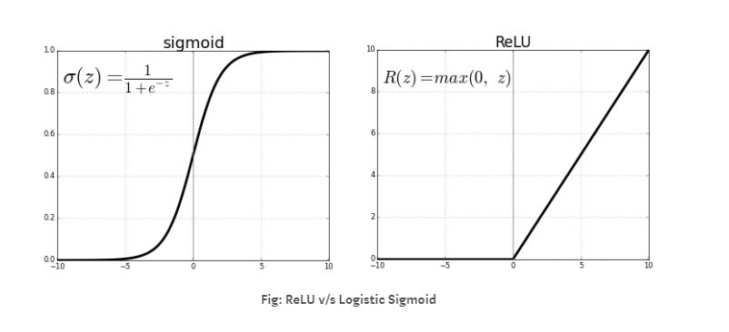

**Figure 4.8:** Logistic Sigmoid versus ReLU function.

The next layer in CNN is *Feature pooling layer* thataggregate the results of the convolutional layers and passes only the relevant and strong signals to the next layers. As it is shown in Figure 4.7, this layer selects the inputs from the small patches in the image where pooling window can have different sizes. In this project, maxPoolingLayer operation is evaluated for accomplishment of the pooling task. Equation 4.2 represents the max pooling function where u(x,y) is a window function that can be applied to each input patch for computing a feature map.

$a_{j }= \max_{N×N}\left(a_{i}^{n×n}u\left(n,n\right)\right)$ (4.2)

Source: Evaluation of Pooling Operations in Convolutional Architectures for Object

The last layer in CNN is the *fully connected (FC) layer* that has a high-level neural network structure. Neurons in this layer are connected to the activations in the previous layer, while activations in this layer are computed via the matrix multiplication with a bias offset.

Source(https://jaai.de/convolutional-neural-networks-cnn-aufbau-funktion-und-anwendungsgebiete-1691/)

Training of the all CNN layers is performed using the backpropagation algorithm to minimize the difference between the desired output and the actual output of the CNNs. Basically, RCNN is considered an outstanding method in object detection. This technique uses CNNs and a support vector machine (SVM) as well as bounding boxes for object detection task. However, each training image should be cropped to a defined size based on the FC layers and repeatedly undergo CNN process which is time-consuming. Consequently, the Fast RCNN was introduced to address these issues. In this approach, a single stage training is performed via multi-task loss process that improve the accuracy and speed of the training. Moreover, with the use of Fast RCNN, the feature caching does not require disk storage as SVM approach. Alternatively, the Softmax layer is inserted directly into the network as a replacement for SVM. This technique exhibits significant improvements in finding reasonable parameters. However, Fast RCNN still have several disadvantages, as it is not enough powerful for real-time applications. Consequently, to improve the performance and speed in Fast RCNN, Faster RCNN approach was proposed. This model proposes regions using a deep fully convolutional network called Region Proposal Network (RPN). Figure 4.9 represents the Faster RCNN configuration.

In comparison with the mentioned frameworks, Faster RCNN (FRCNN) offers certain advantages, and scientists try to develop and improve this approach. Therefore, in this project, Faster RCNN is selected as the framework.

Classification

CONV6

Bbox Regressor



g

CONV5

CONV3

CONV1

Conv Feature maps

Layers from Backboned Model

Input image

Classification

ROI Pooling

Bbox Regressor

FC6

FC7

**Figure 4.9:** Flowchart of Faster region CNN approach

Precision and recall analysis

Generally, there are two criteria in deep learning to evaluate the performance of the detector: average precision (AP) and recall. These parameters are defined as follows:

$average-precision=\frac{True positive}{True positive+True negative}$ (4.3)

$recall=\frac{True positive}{True positive+False negative}$ (4.4)

Where, “False negative’’ is a test result which wrongly indicates that a condition does not hold. “True negative’’ is a test result which correctly identifies that a condition does not hold. “True positive’’ is a result indicating that a given condition exists and it does exist.

In this work, the precision and recall rate of the detector is estimated using all the images in the test set to evaluate the accuracy of the detector. The Average precision result of a detector trained with 53 images is shown in Figure 4.10. The Figure 4.11 represents the automatic detection of the Z-marker with the detector.



**Figure 4.10:** Precision and recall rate plot of the detector. The whole input data is 88 images, with 60 percent for training and 40 percent for testing.

Source: A light and faster regional convolutional neural network for object detection

in optical remote sensing images

**Figure 4.11:** The detected Z-marker in the whole captured image of the MRI screen. In the left image, Z-marker structure is detected correctly, but in the right image the bounding box does not positioned correctly and some other objects from the background detected as the Z-marker.

The average precision of the convolutional network can be improved by adding more images to the data set and increasing the numbers of the convolution layer. However, it is computationally expensive and time-consuming.

#### Noise removal of MRI images

In magnetic resonance (MR) images, noise is commonly represented by means of a Rician distribution, since it is assumed that a zero-mean uncorrelated Gaussian noise exists in both the real and imaginary parts of the k-space MR data. However, this noise affects the results of the processing techniques applied in the MR data, such as registration, segmentation, and localization. Moreover, a tradeoff between noise reduction and the preservation of the relevant image features should be considered. Consequently, several different and robust noise removal methods have been implemented in this project that are applicable to various circumstances.

Image denoising using Gaussian Smoothing Filter

The Gaussian filter is a type of image-smoothing filter that commonly reduces noise by blurring the image. The Gaussian function that is defined in equation 4.5, calculates a transformation for filtering the image based on the standard deviation σ, and the distances x and y of the points from the origin in the horizontal and vertical axes. The equation of a two dimensional Gaussian function is the product of two one dimensional Gaussian functions as:

$G\left(x,y\right)=\frac{1}{2πσ^{2}}e^{-\frac{x^{2}+y^{2}}{2πσ^{2}}}$ (4.5)

Figure 4.10 represents the 2D Gaussian distribution with $σ$ = 1.

**Figure 4.10:** the 2D Gaussian distribution with $σ$ = 1 and mean(0,0).

The Gaussian smoothing filter is applied to the captured MRI images to suppress the Gaussian distributed noise. Figure 4.11 shows the image before and after filtering operation.



**Figure 4.11:** The left image shows the T1W image of the Z-marker structures acquired with capture device and AV converter. The right image shows the denoised image by blurring the image using Gaussian smoothing operation.

Image denoising using wavelets

The nature characteristics of wavelet transforms for preserving the edge features in images make this filter as one of the most applicable denoising technique. By applying the Discrete Wavelets transform (DWT) to an image, the image is decomposed into a series of coefficients, such as: Scaling coefficients (approximation sub-band) and wavelet coefficients (detail sub-band). The DWT tends to dominate small coefficients with low SNR by noise, while coefficients with a large absolute value and high SNR represent more signal information. Therefore, the DWT noise reduction algorithm removes low SNR coefficients and keep the prominent ones, where the Inverse Discrete Wavelet Transform (IDWT) provides the denoised image. The core task of the whole wavelet denoising is to select a suitable threshold for wavelet coefficients that preserves the features of interest in the image and suppress more noise.

One practical technique to find the most suitable threshold for denoising MRI images has been proposed by Donoho [20]. The global threshold in this method that is asymptotically optimal is defined in equation 4.6, where N is the size and σ is the standard deviation of the wavelet coefficients.

$λ=σ\sqrt{2\log{N}}$ (4.6)

Afterwards, Hard or Soft thresholding technique is used to apply the computed optimal threshold from the equation 4.6 to the wavelet coefficients. The mathematical definition of both methods are shown in equation 4.7 and 4.8 where c is the coefficient array.

$\overline{c_{h}}\left(k\right)=\left\{\begin{aligned}sign\left(c\left(k\right)\right)\left(\left|c\left(k\right)\right|\right) if \left|c\left(k\right)\right|>λ \\ 0 if \left|c\left(k\right)\right|≤λ\end{aligned}\right.$ (4.7)

$\overline{c_{s}}\left(k\right)=\left\{\begin{aligned}sign\left(c\left(k\right)\right)\left(\left|c\left(k\right)\right|-λ\right) if \left|c\left(k\right)\right|>λ \\ 0 if \left|c\left(k\right)\right|≤λ\end{aligned}\right.$ (4.8)

Figure 4.12 represents the behaviors of the thresholding functions defined in equations 4.7 and 4.8 on a linear signal.

a) original signal

b) Hard thresholded signal

c) Soft thresholded signal

signal signal

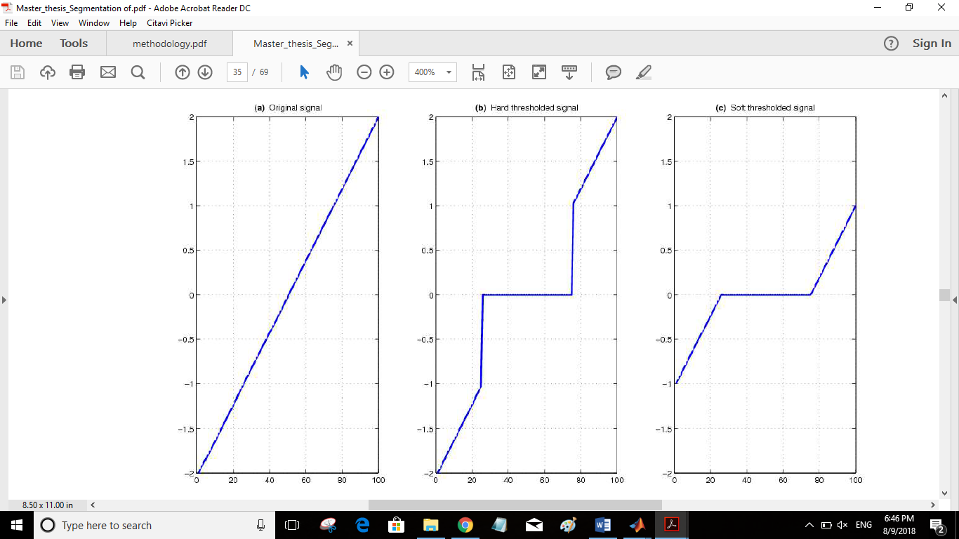

**Figure 4.12:** Theresholding of a linear signal defined in the range [0,2] with λ=1 by (b) Hard thresholding and c) Soft thresholding.

The result of the proposed denoising method for the captured MRI image is represented in Figure 4.13.



**Figure 4.13:** the left image represents the original image, and the right image shows the filtered image using wavelet with soft theresholdig method.

Image denoising using Nonlinear Anisotropic Filtering

The main drawback of the linear filtering mentioned in sections 4.2.2.1 and 4.2.2.2 is that the details in the original image will be destroyed during reducing the noise. Anisotropic diffusion filtering proposed by Perona and Malic [reference] is a method which reduces the image noise while preserves important details such as edges in the image. This filter is defined as an anisotropic process which uses an adapted diffusion tensor for smoothing the images. Importantly, the diffusive procedure is an inhomogeneous process which limits the smoothing in areas of interest which have a larger likelihood to be edges or boundaries.

The Perona-Malik filter performance is based on the mathematical formulation given in equation 4.9, where the rate of diffusion can be controlled with the diffusion coefficient c(x,y,t).

$\frac{∂}{∂t}I \left(x,y,t\right)=div(c\left(x,y,t\right)∇I\left(x,y,t\right))$ (4.9)

I(x,y,t) represents the image intensity and div and $∇$ denote the divergence and the gradient operators respectively. Moreover, x and y represent the spatial coordinates in the two-dimensional image, and t corresponds to the iteration number.

An important step in this technique is to select an appropriate diffusion coefficient based on the image gradient. Ideally, the coefficient should be 0 at the features of interest (edges and boundaries), and 1 at the interior of a region. Accordingly, Perona and Malik [] introduced the two mathematical equations 4.10 and 4.11 for estimating the diffusion coefficient, where the first equation has a better performance on the high contrast edges, and the second one is more suitable for the wide areas rather than the narrow ones.

$c_{1}\left(x,y,t\right)=exp⁡({⁡-(\frac{\left|∇I\left(x,y,t\right)\right|}{k})}^{2}$ (4.10)

$c_{2}\left(x,y,t\right)=\frac{1}{1+({⁡(\frac{\left|∇I\left(x,y,t\right)\right|}{k})}^{2}}$ (4.11)

In the equations 4.10 and 4.11, k is conductance parameter, and usually can be selected empirically. Moreover, it determines the difference between an edge and an intensity value destroyed by noise during anisotropic diffusion filtering process.

In addition, the diffusive procedure which applies the eq.4.9 defines the intensity change in each iteration based on the summation of contributed pixels at the neighborhoods of (x,y) which are weighted according to equation 4.12, as presented in equation 4.13.

$$Φ_{E}\left(x,y,t\right)=c\left(x+\frac{dx}{2},y,t\right)[I\left(x+dx,y,t\right)-I\left(x,y,t\right)]$$

$$Φ_{W}\left(x,y,t\right)=c\left(x-\frac{dx}{2},y,t\right)[I\left(x,y,t\right)-I\left(x-dx,y,t\right)]$$

$$Φ_{N}\left(x,y,t\right)=c\left(x,y+\frac{dy}{2},t\right)[I\left(x,y+dy,t\right)-I\left(x,y,t\right)]$$

$Φ_{N}\left(x,y,t\right)=c\left(x,y-\frac{dy}{2},t\right)[I\left(x,y,t\right)-I\left(x,y-dy,t\right)]$ (4.12)

$I\left(x,y,t+dt\right)=I\left(x,y,t\right)+dt\left[\frac{1}{{dx}^{2}}\left[Φ_{E}\left(x,y,t\right)-Φ_{W}\left(x,y,t\right)\right]+\frac{1}{{dy}^{2}}\left[Φ_{N}\left(x,y,t\right)-Φ_{S}\left(x,y,t\right)\right]\right]$ (4.13)

In the equations 4.12 and 4.13, the pixel spacing in the image is represented by dx and dy Moreover, in equation 4.13, dt corresponds to the integration constant and it has to be selected with respect to a stability criterion. Figure 4.14 shows an image which is denoised using anisotropic filter after binarization.



**Figure 4.14:** The left image is the original image and the right image is the denoised image using anisotropic filter after binarization. Equation 4.11 is used to for estimation of the diffusing coefficient.

In conclusion, based on the results presented in Figure 4.14, the anisotropic diffusion filtering approach has the best performance on the images as a preprocessing step (noise reduction and edge enhancement). Moreover, due to the mentioned characteristics of the anisotropic diffusion, the image converges faster to the desired shape for further processing.

#### Image Contrast Enhancement

In order to adjust the intensity value in the image, the *imadjust* function in MATLAB is implemented, while the range of the input values and the output values are specified in two vectors that pass to the *imadjust* function as arguments. The first vector specifies the low- and high-intensity values that must be mapped and the second vector specifies the scale over which the values of the first vector should be mapped to. The result of this process is represented in Figure 4.15.



#### Image Binarization

Thresholding is a common image processing technique applied to gray-scale images for image binarization. In general, it makes a binary partition of the image data set by using intensity values of the image pixels. Single-threshold algorithm separates the dataset into two classes based on a threshold, where, pixels with higher intensities than the threshold are categorized into one class and the other pixels are categorized in an another class. The mathematical equation of this technique is presented in eq. 3.1, where I and $λ$ correspond to the analysed intensity value the threshold respectively. This method is also called segmentation.



The difficulty in this approach is that the threshold value should be determined in a way that best differentiate the regions of interest. Practically, the result of the filter depends on the threshold value, MRI noise and inhomogeneities.

In this project, in order to distinguish between the cylindrical fiducials and the background, the user has to select a threshold based on visual inspection of the image. Therefore, any pixel for which is bigger than a threshold labeled 1 and corresponds to the fiducial maker; otherwise, the pixel corresponds to the background and labeled 0.



#### Binary Image Mask

At this stage, each segment which is detected as a fiducial marker, is examined based on its volume and dimensions. If the volume in a given segment is lower than a pre-defined range, it does not belong to the Z-frame structures, and should be removed from the image. Therefore, function *bwareaopen* in MATLAB is used to create a binary mask and remove small segments from the image as it is shown in Figure .

However, Z-marker with Z-axis indication triangle requires a filtering method to remove the triangle which has a size bigger than the 7 fiducial markers in different angulations. For this purpose, a polygonal region of interest (ROI) mask is implemented which creates an interactive polygon tools for selecting a ROI. The mask sets pixels inside ROI to 0 and other pixels to 1. Figure illustrates the interactive tool for selecting and adjusting polygon vertices on the image using the mouse.



Polygon vertices

**Figure :** The left image shows the first image masking method using a threshold to withdraw small objects from the background. The right image represents the polygonal masking technique to remove the triangle structure from the image.

### Localization and Registration

This section is dedicated to the implemented methods for localization and registration of the Z-frame marker in the MRI image space. The flowchart of the procedures is illustrated in the Figure 4.2. Here, each stage is explained in a subsection and the result is of them is represented and investigated.

#### Center Detection of the Fiducial Ellipses

Once all 7 ellipses with the size close to the physical size of the marker were detected, the function *regionprops* in MATLAB is used to calculate the center of each fiducial marker. The result is a 7×2 matrix where the first column represents x coordinate and the second column corresponds to y coordinate of the center of the fiducial mass region. The resulting 7 centroids of the ellipses were sorted along the U-shape of the marker as illustrated in Fig.2

Depending on the attachment of the Z-frame on the robotic device, the frame has different position, scale, and orientation in the MR images, hence, the points are not always detected in the same way. Accordingly, a robust technique is required to rotate the Z-marker around its axis on the image automatically.



**Figure:** This image illustrates the binary image with centroid locations of the seven fiducial markers. The accurate position of the centroids depends on the pre-processing stage for preserving more relevant signal and suppressing noise.

#### Image Rotation Estimation using Automated Feature Matching

Feature matching method, automatically determines a geometric transformation between two images that are different by a rotation or a scale change. Importantly, the features in both images should be detected with an optimal feature detection technique which is robust to rotation, scale, illumination, and noise of the images. Scale Invariant Feature Transform (SIFT) is a feature detector proposed by Lowe. SIFT is an efficient detector in object recognition applications that is invariant of the rotation, intensity and viewpoint changes in image. However, the main drawback of SIFT is the time-consuming feature computation procedure. Alternatively, Speed up Robust Feature (SURF) technique, with the same principle of SIFT, has a higher computational speed without reducing the quality of the detected features. It has to be mentioned that both SIFT and SURF methods are based on a detector and a descriptor. In this project, both SIFT and SURF are implemented. Once, the image features and descriptors are detected, the corresponding features in each image will be matched. The point matched are shown in Fig. Therefore, a transformation matrix based on the matching point pairs is computing using the statistically robust M-estimator SAmple Consensus (MSAC) algorithm. Matching point pairs used in the estimation of the transformation matrix is displayed in Fig.2. The desired angle of rotation is calculated using the geometric transform from the last step. The recovered and the reference image is shown in Fig. This technique requires the detected features be highly distinctive to be correctly matched with high probability.

However, the fiducial markers have a different shape in different imaging slices. In addition, artefacts and noises in MRI have an effect in the roundness of ellipses which make the algorithm unable to find the match features in the images as it is figured in Fig..



#### Image Rotation using centroids coordinate system:

In this technique, the seven centroids position of fiducial markers is used to compute a rotation matrix that rotates the points in the image coordinate system. Since the four outer points of the Z-marker has a constant distance to each other, the points with maxim Euclidean distances with its three neighbors are detected as the outer points. Once all four outer points are detected, the correct position of them should be determined in z marker. The point with minimum x coordinate is detected as p1 and one with maximum x is determines as p7, however, their y coordinates should be compared for an accurate estimation. Totally, four different rotation models of the Z-marker are possible, which algorithm should select automatically the correct one and rotate the marker based on that. As it is figured in Fig.1.





Fig .15: Four different possible rotation of the Z-marker

D=270

D=180

D=0

D=90

innerpoint

innerpoint

In the next step, the algorithm detects the nearest neighbors of the p1, if it has only one neighbor, the z marker has one of the fig a or b, and if it has two neighbors fig c and d are possible. Then, algorithm searches for a point called *innerpoint,* which is located between p1 or p7 and the point with a minimum y coordinate as it is shown in Fig.1. Hence, one type of the rotation is determined by the algorithm. The rotation angle 𝜃 is defined in equation1.

𝜃=β+D

β= 𝛼-45

Where 𝛼 is the angle between the line that is made by p1 and p7, and the line which passes through p1 and is parallel to the y axis as it is presented in Fig1. D corresponds to the defined angle that is different in each model for making the z marker as a U shape structure. Therefore, a rotation matrix is calculated to be multiplied with the centroids matrix. The ordered set of fiducial point coordinates *P’* are then applied to compute the 6-DOF pose of the Z-frame with respect to the image plane. Finally, the computed frame position and orientation is used to compute the required motion of the robotic device to reach the target pose.

#### Distance calculation and calibration

In the calibration part, a coefficient should be calculated to transfer points from image coordinate system to the frame coordinate system. In DICOM images, pixel spacing is defined as the physical distance between the centers of each two-dimensional pixel. However, in screen shot images, the resolution of the MRI monitor and the capture device influence the distance. To overcome this problems, a coefficient is calculated based on equation 1. Where, *µx* is the row spacing or vertical spacing in mm, *µy* is the column spacing or horizontal spacing in mm, Pi is the center points of the fiducial markers and d is the Euclidean distance between points. d’ is the distance between points in physical space in mm.

µx = (|d’/d (P5, P3) |+abs|40/d (P1, P7) |)/2

µy = (|d’/d (P3, P1) |+abs|40/d (P5, P7) |)/2

Figure represents the pixel spacing in vertical and horizontal direction.

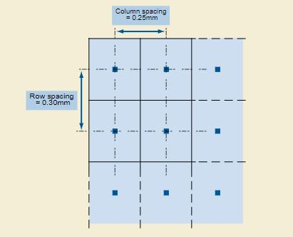

Figure ‎4.2 Example of Pixel Spacing Value Order

Source: https://dicom.innolitics.com/ciods/ct-image/image-plane/00280030

In the next step, the coordinate of the centers is transferred to the center of the z-marker.



#### Marker Alignment Calculations

Once the center of all 7 fiducials was calculated and calibrated, the position of the three corresponding points in frame coordinate system is estimated according to equation 1, and 2. Where $f_{i}$ is a function that measures the fraction along the length of the frame at which each diagonal cylinder is imaged, and p*iMR*  is the centroid of ellipse *i* identified in MR image.

$\left[p_{2f } p_{4f} p_{6f}\right]$ =

$\left[\begin{aligned}l_{x}\left\{-\frac{1}{2} \frac{1}{2}-f_{4 } \frac{1}{2}\right\} \\ l_{y} \left\{\frac{1}{2}-f_{2} \frac{1}{2} -\frac{1}{2}+f_{6}\right\} \\ l_{z}\left\{-\frac{1}{2}+f_{2} -\frac{1}{2}+f_{4} -\frac{1}{2}+f_{6}\right\}\end{aligned}\right]$

$$f_{i}=\frac{\left|p_{(i+1)MR}-p_{iMR}\right|}{\left|p_{(i+1)MR}-p_{(i-1)MR}\right|}$$

#### Angle Calculation of the MR Image Plane and Z-Marker

In this stage, the angle between MR image plane and the Z_marker is calculated to confirm the parallelization of the marker. When the MRI plane and the Z-marker plane intersect, an angle between them is formed that can be calculated by the use of normal vectors of the given planes according to equation. The equations of two intersecting planes and their normal vectors are given by equations 1 and 2:

∏1: a1x+b1y+c1z+d1=0

∏2: a2x+b2y+c2z+d2=0

= normal vector to plane ∏1 = (a1, b1, c1)

= normal vector to plane ∏2 = (a2, b2, c2)

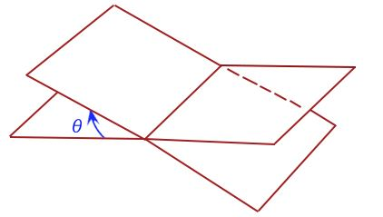

**Figure :** This image illustratesThe two intersected planes which create angle Ɵ.

Therefore, the rotation angle of the Z-marker around x and y axis are calculated using normal vector of the plane containing three corresponding points P2, P4, and P6 in the Z-marker coordinate system. The angle between the Z-marker plane and yz plane determines rotation around x axis, and the angle between the Z-marker plane and xz plane ascertains the rotation around y axis. In the figure 1, the gray plane is the Z-marker plane including P2, P4 and P6 coordinates which is rotated +10 degrees around both x and y axis. The white plane is the optimal plane that Z-marker should reach after -10 degrees’ rotation of the MRI plane or Z-marker around both x and y axes.



**Figure :** The Z-marker plane including p2, p4 and p6 coordinate systems. The plane is plotted after processing of the captured MRI image and extracting and computing the centroids of the fiducial markers.

In the coronal view of the Z-marker in the MRI coordinate system, the sagittal plane represents the y axis and the transversal plane indicates the x axis. Accordingly, the clinician should rotate the MRI plane -10 degrees both around sagittal and transversal planes to make the Z-marker parallel to the MRI plane. As it is shown in the Figure, the Z-marker plane (gray plane) is close to the optimal plane (grid plane) after MRI plane rotation which proof the parallelization of the marker to the MRI plane.



Figure:

Moreover, the right rotation of the marker around x and y axis has to be estimated to find a correct rotation of the robotic device. Therefore, the Z-axis indication triangle feature discussed in the section 3 is used to determine the z-axis direction in the image coordinate system.

The rotation direction around y axis is estimated using the z axis values of the centroids p2 and p6. If p2 has a higher z value and the triangle is in the left side, it shows that rotation is positive, otherwise the rotation is negative. In the case that triangle is in the right side of the marker, the z axis has to be inverted and bigger z value of p2 represent the negative rotation around y axis. In addition, the rotation around x axis is indicated using z coordinates of p4 and one of the p2 and p4 centroids.

Registration error distribution of the z-marker

An accurate registration of the Z-marker requires the true localization of the fiducials. However, in real world, localizing fiducials usually is not errorless and results in appearing an error known as fiducial localization error (FLE) that results in two registration errors known as fiducial registration (FRE) and target registration error (TRE). FRE is defined as the error in aligning corresponding fiducials after the registration, and TRE is defined as the error in aligning corresponding targets after the registration. TRE is an important measure in defining the accuracy of a fiducial system during the surgery. However, calculating the actual TRE at a target location during a surgery is difficult and time consuming. Instead, measuring FRE during the surgery after localization and registration of the fiducials is simple. Accordingly, FRE determines the accuracy of the fiducial localization. (the distribution… paperr)

## Graphical user interface implementation

The automatic alignment detection algorithm of the Z-marker which utilizes the process described in section 4 has been accomplished in a Graphical User Interface designed in MATLAB R2017a. The implemented GUI displays only required information which enables the user to easily interact with the several processing stages.

The flowchart of the proposed algorithm for alignment detection and angle calculation of the Z-marker in GUI is represented in Figure 5.1.

Entering MRI and Z-marker parameters

Z-frame segmentation

Image

pre-processing

Fiducial center detection

Alignment detection

Calibration

Rotation adjustment

Importing image/ Triggering capture device

**Figure 5.1:** the process flowchart of the implemented algorithm in GUI

The first two steps are importing the image to the workspace and entering the required parameters for the processing steps. The segmentation, pre-processing, center detection and the calibration steps includes both automatic and manual options that user can select one of them to process the image. A brief description of the buttons and panels used in designing of the GUI is given here.



* *Import image* panel. It includes a popupmenu button for either selecting the path of the saved image or triggering a capture device or a camera for acquiring an image in a real-time workflow.



* *Input parameters* panel:In this step, the user has to enter several parameters of the imaging and physical setup properties. It includes pixel spacing from the MRI header, Z-marker size, MRI monitor resolution, and direction view of the marker. all this information is used further on in the calibration stage.



* *Z-frame segmentation* panel: In the segmentation step, the user has two options to extract the Z-marker from the captured MRI image. The manual button implements the cropping method and automatic one applies the neural network explained in section 4.
* *Image pre-processing* panel: In the automatic part of the image pre-processing stage, the Gaussian filter, contrast enhancement and binarization and masking methods with an average threshold are implemented. The manual part of this stage compromises several noise removal techniques (Gaussian filter, Wavelet filter, Anisotropic filter), contrast enhancement, binarization and thresholding methods, which threshold of each of these steps can be controlled using a slider. Moreover, there are two buttons for black and white pen in the manual section which the thickness of the tip of the pen can be controlled using a slider. The black pen can be used for removing the object that do not belong to the 7 fiducial markers such as center pointing triangles, and Z-axis indication triangle. The white pen can be applied to add pixels to the fiducials which are distorted by noise or artifacts in MRI. This process improves the accuracy of the center detection stage which depends on the pixels in each fiducial. However, if the processed image using automatic button is not good enough for the next step, user can use the manual section sliders to process the image.





* *Center detection* panel: In this step, the center detection algorithm which is discussed in section 4 is applied to the binarized image produced in the previous step. In the automatic part, the center of each volume is detected, and if there are more than 7 detected centroids, an error is displayed on the screen that the user has to repeat the image pre-processing stage. In the manual part, the user has to analyze each centroid to make sure the centroid is detected in the center of each fiducial markers. Therefore, user can drag and drop the detected centroids to the right position.



* *Calibration* panel: It implements the procedure explained in the distance calculation and calibration in section 4. In addition, in this step, the rotation of the Z-marker in the image using the coordinate system of the centroids is calculated based on the method develop in the section 4.
* *Alignment detection* panel: in this step, alignment of the Z-marker is calculated based on the mathematical formulation discussed in section 4. Moreover, the angles of the Z-marker and image plane is calculated as developed in section 4, and the required rotation around x and y axis are displayed.



* *Robotic rotation adjustment* panel: In this stage, the rotation angle calculated in the last step is transformed to the required rotation of the robotic or mechanical device to make the Z-marker parallel to the image plane. s

## Z-frame marker characterization

### Z-frame physical structures

In this project, the new physical feature structures of the Z-frame have been developed which improve the accuracy and speed of the registration procedure in the interventional MRI. Figure 3.4 illustrates the two new features: center pointing triangles (8 small purple triangles) and the z-axis indication triangle (the green triangle).



Figure ‎3.4: A 3D view of the Z-marker structures.

#### Center pointing triangles

A successful intervention under MRI depends mostly on the accurate determination of the position of the needle insertion point based on the target pose. Generally, the needle entry point is indicated by producing an artefact by surgeon finger in real-time image acquisition. However, the alignment of the image plane based on the artefacts leads to an uncertain localization and tracking.

In our approach, the center pointing triangles allows an accurate alignment of the image planes according to the center of the marker. Figure 1 shows a coronal view of the Z-marker in which the green line is the transversal plane and red line indicates the sagittal plane of the MRI. In order to align the two planes in the center of the Z-marker accurately, the cross-section point of the two planes should be aligned with the four inner triangle shapes.

Figure ‎3.5: a: a coronal view of the Z-marker shows the two planesnearly close to the center of the Z-marker. b: sagittal view of the Z-marker and a liver phantom. c: transversal view of the Z-marker and the liver phantom.



#### Z-axis indication triangle

After localization and registration of the instrument, an accurate guidance of the instruments required to reach the target. Consequently, the coordinate system of the Z-marker should be determined in the MRI and image coordinate system. The correct coordinate of the marker can be detected based on the Z-axis indication triangle position in the image. For example, if the triangle structure is in the right side of the marker, the top view of the marker is visualized and the coordinate system is defined as shown in Fig.1. On the other hand, if the triangle is in the left side of the marker, the coordinate system is inverted since it has bottom view as it is shown in Fig.2. The significant role of this feature is the determination of the correct rotation direction of the Z-marker which discussed in the section 4.2.



Figure ‎3.6:

#### Squared-shaped internal tunnel structure

The automated alignment detection algorithm depends on the accuracy of the detected centroids of the fiducial markers. However, the coordinates of the fiducial markers may not be accurately estimated due to suboptimal imaging techniques. The squared shape tunnels provide the ability to estimate the pixel distortion at the edges which is easier for the retrieval of the related signals and accurate identification of the centroids coordinate system.

### Z-frame marker spectroscopy

For magnetic resonance imaging (MRI) guided minimal-invasive procedures the visualization of therapeutical instruments for biopsies, catheter placements, and tissue ablations, is absolutely essential. However, MR safe instruments usually are ― depending on the material used ― either not visible at all or only indirectly visible due to susceptibility artifacts generated by the device material.

With prior knowledge of the resin´s relaxation times, the optimal resin for a given imaging protocol (e.g. liver biopsy) could be determined before marker fabrication. Each resin has a different, but unknown chemical composition and, thus, potentially different longitudinal (T1) and transversal (T2) relaxation times. The contrast in MRI is largely driven by these relaxation times [3]. Therefore, the visibility of the liquid resin within the marker depends on the used imaging protocol and relaxation properties of the resin.

As a first step to enable MRI markers personalized to a given imaging scenario, this section aims to establish a protocol to determine T1 and T2 relaxation times of the resins used in the stereolithography process.

#### Determination of the resin relaxation times

T1 and T2 relaxation times are experimentally determined for the initially selected stereolithography resins: VisiJet SL Tough, VisiJet SL Clear both from 3D Systems, Inc., and Formlabs FLGPWH03 from Formlabs Inc. Each of the three resins have been stored in separate containers before placing them inside a transmit–receive birdcage head coil of a 3T Skyra MRI system (Siemens Healthineers, Germany).

Measurements are acquired with a spin echo (SE) sequence using a single 4 mm thick slice with 1 mm in-plane resolution. For T1 estimation an inversion recovery pulse is included and the inversion time (TI) is varied between measurements (five different TIs between 23 ms and 2,000 ms). For the T2 estimation the echo time (TE) of the SE is varied accordingly (five different TEs between 5.5 ms and 200 ms), see Figure 1.

Relaxation times are then calculated for each resin within automatically computed region of interests (based on image thresholding). For each voxel within the region of interest a mono exponential decay is fitted to the signal evolution over TI/TE. The final relaxation time is computed as the mean ± standard deviation over all voxel for a given resin. For the T1 relaxation the following signal equation is used [4]:

$$S\left(TI\right)=S_{0}(1-2e^{-\frac{TI}{T1}})$$

with $S(TI)$ as the mean measured signal at TI and $S_{0}$ capturing residual T2 weighting, proton density, and coil sensitivities. For the T2 relaxation time the following signal equation is used [4]:

$$S\left(TE\right)=S_{0}e^{-\frac{TE}{T2}}$$

with $S(TE)$ as the mean measured signal at TE and $S_{0}$ capturing proton density, and coil sensitivities. Goodness of fit is evaluated with the coefficient of determination $(R²$).

All processing is done in MATLAB 2015b (MathWorks, USA).



Figure ‎3.7: Measured image slice of the three cylindrical resin containers (left: VisiJet SL Tough, middle: VisiJet SL Clear, right: Formlabs FLGPWH03)

#### Experimental results

The T1 and T2 relaxation times (see Tab.1) of the tested resins are calculated based on the experimental results. Fig. 2 shows the mean fitted relaxation time compared to the measured signal. The overall goodness of fit for all estimates is high (R²>0.99).

T1 estimates for all resins differed among each other by up to 9.97 % and has an average T1 relaxation time of 164.4 ms, which is considerably shorter than human tissue such as subcutaneous fat (382 ms), liver (809 ms), or the medulla of the kidney (1,545 ms) [5].

T2 estimates for all resins differed among each other by up to 10.74 % and had an average T2 relaxation time of 22.3 ms, which is shorter than human tissue such as subcutaneous fat (68 ms), liver (34 ms), or the medulla of the kidney (81 ms) [5].

|  |  |  |
| --- | --- | --- |
| Resin | T1 Relaxation Time [ms] | T2 Relaxation Time [ms] |
| VisiJet SL Tough | 156.7 ± 2.9 | 23.2 ± 0.8 |
| VisiJet SL Clear | 174.0 ± 16.7 | 20.7 ± 1.0 |
| Formlabs FLGPWH03 | 162.6 ± 3.6 | 22.9 ± 1.2 |

Table 1: Estimated mean ± standard deviation T1 and T2 relaxation times for three different resins



Figure ‎3.8: : Comparison of measured and estimated T1 and T2 relaxation times for three different resins. Measured data of the normalized signal intensity is shown as error bars (mean ± standard deviation). After fitting the signal model (using the mean T1/T2 from Tab.1) the estimated relaxation curve is overlaid.

#### Outlook

This study determines the MRI T1 and T2 relaxation times for resins used to serve as MRI marker material for the first time. In the future, these results will enable to predict the marker visibility before scanning. Thus, for a given scenario in interventional MRI application (e.g. liver biopsy) the optimal marker can be fabricated with the optimal resin. However, relaxation times for more resins should be estimated in the future as the measured resins do not vary considerably among each other, limiting the potential for personalizing interventional applications through T1 and T2 relaxation time matching. Furthermore, extending the signal equation and MR measurement to account for system imperfections (e.g. imperfect inversion pulses, or transmit and receive inhomogeneities) might improve the estimates.

## MR-compatible rotatory frame

In order to determine the registration accuracy, a rotatory positioning platform using Lego is built as it is shown in Figure. As the ground through, relative positions and orientations were tested in the experiment. Several groups of images were taken at each position and orientation

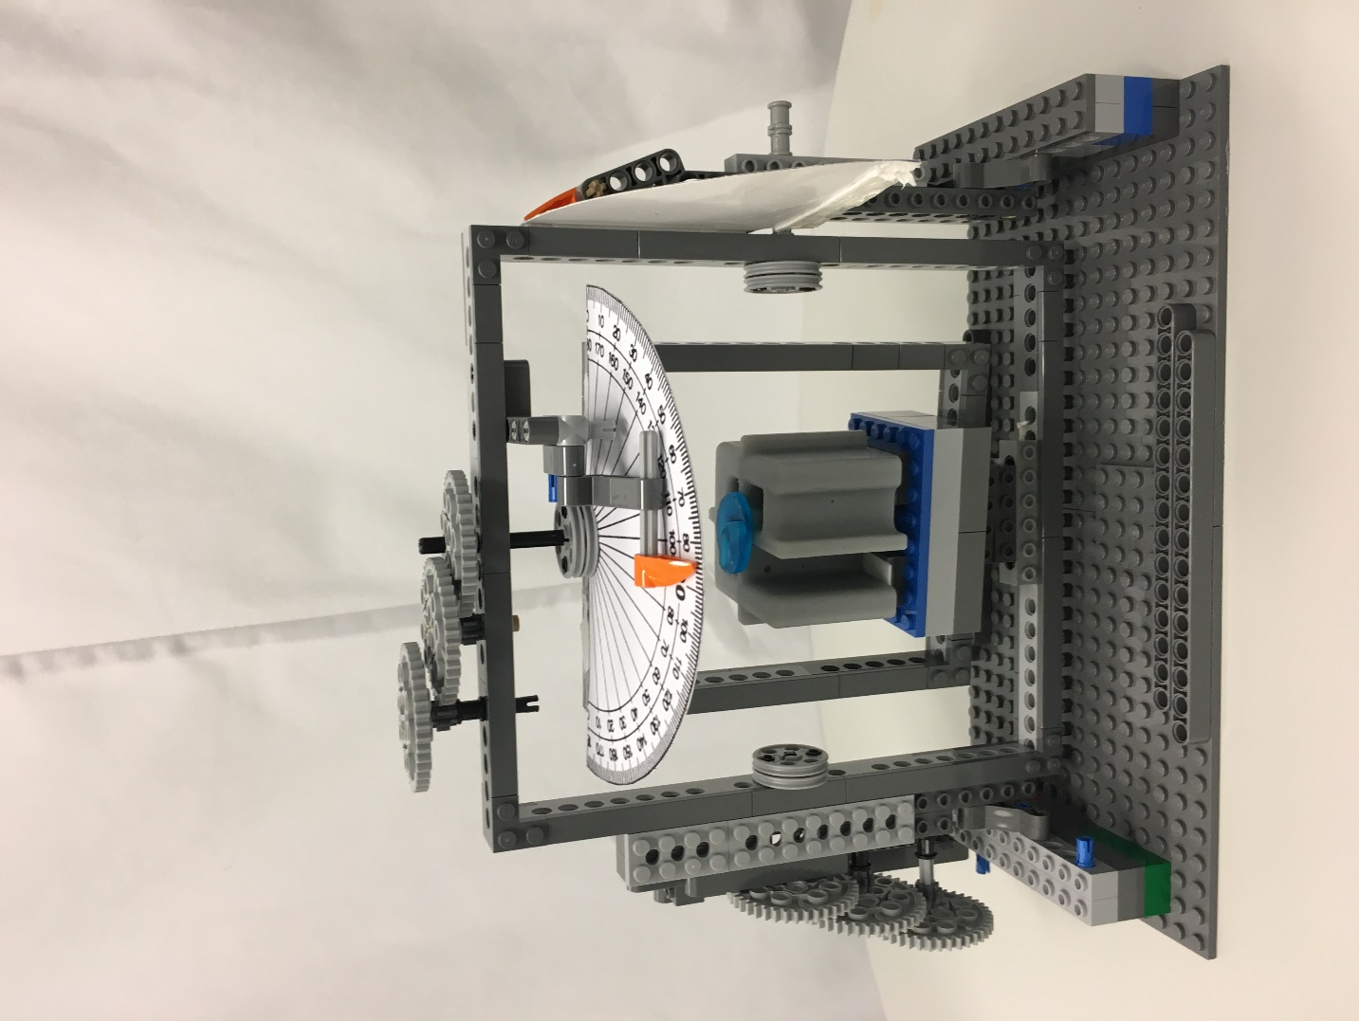



# Testing

# Results

## Accuracy study

In this section, the accuracy of the software algorithm is investigated.

### CAD model

|  |  |  |
| --- | --- | --- |
|  | Rotation around x axis | Rotation around y axis |
| CAD model | -8.04 | -5.19 |
| Algorithm calculation | -7.67, -7.35, | -5.06 -5.25 |
| CAD model | -8.04 | -5.19 |
| Algorithm calculation | -7.67 -7.35 | -5.06 -5.25 |
| CAD model | -8.04 | -5.19 |
| Algorithm calculation | -7.67 -7.35 | -5.06 -5.25 |
| CAD model | -8.04 | -5.19 |
| Algorithm calculation | -7.67 -7.35 | -5.06 -5.25 |
| CAD model | -8.04 | -5.19 |
| Algorithm calculation | -7.67 -7.35 | -5.06 -5.25 |
| CAD model | -8.04 | -5.19 |
| Algorithm calculation | -7.67 -7.35 | -5.06 -5.25 |
| CAD model | -8.04 | -5.19 |
| Algorithm calculation | -7.67 -7.35 | -5.06 -5.25 |
| CAD model | -8.04 | -5.19 |
| Algorithm calculation | -7.67 -7.35 | -5.06 -5.25 |
| CAD model | -8.04 | -5.19 |
| Algorithm calculation | -7.67 -7.35 | -5.06 -5.25 |
| CAD model | -8.04 | -5.19 |
| Algorithm calculation | -7.67 -7.35 | -5.06 -5.25 |
| CAD model | -8.04 | -5.19 |
| Algorithm calculation | -7.67 -7.35 | -5.06 -5.25 |
| CAD model | -8.04 | -5.19 |
| Algorithm calculation | -7.67 -7.35 | -5.06 -5.25 |

5.2.2 Experimental setup

# Conclusion and outlook

This chapter discusses about the achievements of this work which the results are evaluated and concluded. The suggestions for further work are introduced.

This work is a part of for development of a system for faster handling of interventional procedures using MRI. An automated approach is developed to align the interventional tools along a defined trajectory in iMRI. An application, which interacts with the user for an accurate detection, tracking and registration, has been accomplished.

In addition, the designed algorithm has to take into account the limitations which might be encountered during the instrument alignment process. In order to find the appropriate methods in each stage of processing, an investigation has been conducted.

Gasussian filter has been compared with Wavelet-based denoisng and anisotropic filtering, and the last one has been selected for denoising of captured MRI images due to its efficiency in suppressing the noise and preserving the features of interest. A contrast enhancement method has been used for improving the contrast of the images. The centers of each fiducial is calculated based in the connected components in the image.

For the automatic segmentation of the Z-marker structures in the images, a Faster-RCNN algorithm has been used, considering that the Z-marker might have different scale, rotation and position in the images. In order to estimate the image rotation, the automated feature matching technique using SIFT and SURF features, and a mathematical technique based on the fiducials coordinate system have been implemented, while the latter is used, as it is the most accurate in determination of the rotation in the images. The approach also takes into consideration the change of the inner fiducial shapes in different slices. A series of mathematical formulations have been applied to calculate the alignment of the marker in MRI coordinate system and estimate the required rotation angle of the Z-marker to make it parallel to the image plane. It includes the rotation angle and direction of the Z-marker around x and y axes.

The detection alignment algorithm is tested on 50 images of the Z-marker, on 3 different angles. It proved to have high performance in … and the results have been compared with manual generated grouth truth.

Outlook

This thesis includes a comprehensive analysis of an automated alignment detection of an additively manufactured Z_marker during iMRI. Further work can be undertaken to eider improving the detection algorithm which can detect the centroids very accurate from capture MRI images. It can compensate the artefacts and noises which destroy some pixels.

Related to the …, several aspects can be improved

* Extension of the proposed algorithm to calculate the translation of the Z-marker if it is far away from the target. The main concern in this case is
* Another enhancement of the application would refer to automatically segmentation of the Z-marker form the full screen images. As the algorithm …. , this can be a very difficult task to achieve. In some cases the Z-marker structures can be easily identifies, based on their shape, but in other cases ( depending on the position and configuration of the Z-marker and also on the MRI signal, Z-marker has different appearances, shape and gray level distribution. ….. so the shape information cannot be used for the decision.
* An additional suggestion refers to computation time improvement. As it is known that
* micropositioning

For this part look at the article “automated fiducial marker detection for patient registration …”.

. (2012SPIE_Zframe)

. Conventional registration methods usually …. In robotically assisted surgery, the end-effector of a robot can be registered to the scanner using a rigid body fiducial frame attached to the end-effector. However, this technique has a common problem that robot moves the fiducial frame out of the field of view, causing the image slice to become incomplete for registration. Figure 3? Illustrates an image of Masamun’s device with an incomplete number of fiducial rods. Traditional methods cannot handle this problem without acquiring extra images, which costs time. (numerical algorithm for spatial ...).

The algorithm has following advantageous:

It is resistant to noise in the input data. One of the input to the registration algorithm I the two-dimensional coordinates of the fiducials marks in the cross-sectional image. This information is produced by an image processing program at I not the subject of this investigation. It is conceivable that the locations of fiducial marks are not exactly identified in the medical images, due to suboptimal imaging and image processing techniques. These errors are considered to be “noise” in the input to the registration algorithm.

The algorithms must also run reasonably fast, in order to be useful in intraoperative applications. Computation time longer than one second? Would be prohibitive.